Janice Ainembabazi

Southern New Hampshire University

CS-340-18683-M01 Client/Server Development

Prof. Jeff Sanford

November 24th 2024

I started by navigating to the dataset directory using the cd command to ensure I was in the correct location to work with the required data. Then, I imported a CSV file into a MongoDB database using the mongoimport command. This step involved specifying the necessary authentication details, database name, and collection name while ensuring the existing data in the collection was replaced using the --drop option. The import was successful, with 10,000 documents added to the database.

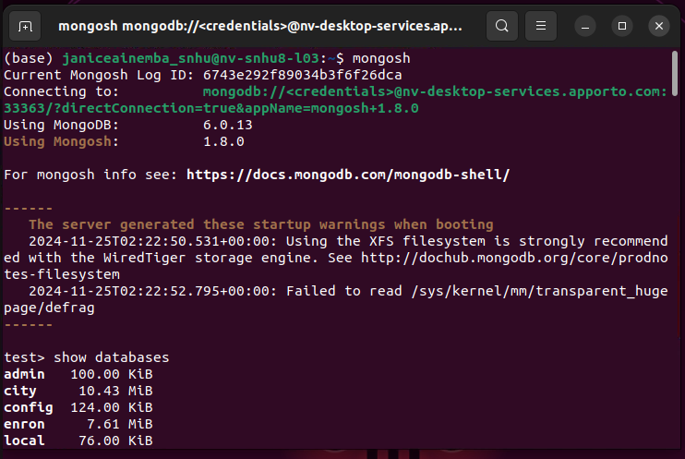

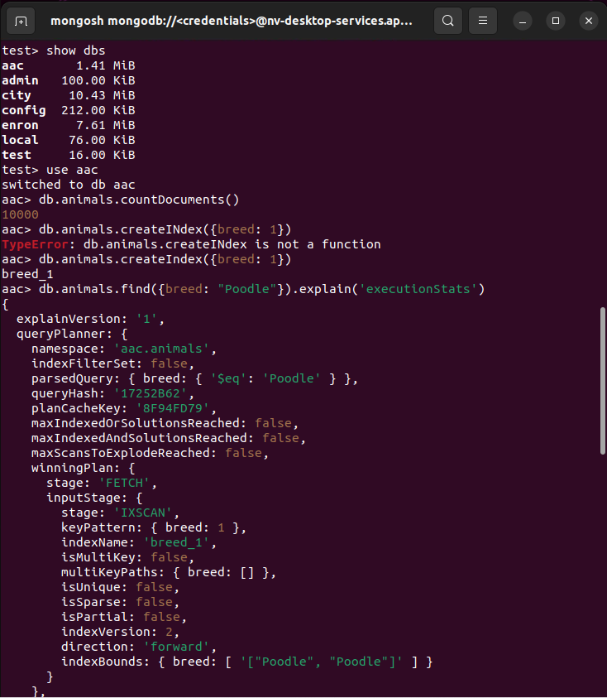

I connected to the MongoDB shell using mongosh to interact with the database. I verified the databases available on the server using the show dbs command and confirmed the successful addition of the "aac" database. I created an index on the "breed" field within the "animals" collection to optimize query performance. To further improve efficiency, I also created a compound index on both the "breed" and "outcome_type" fields.

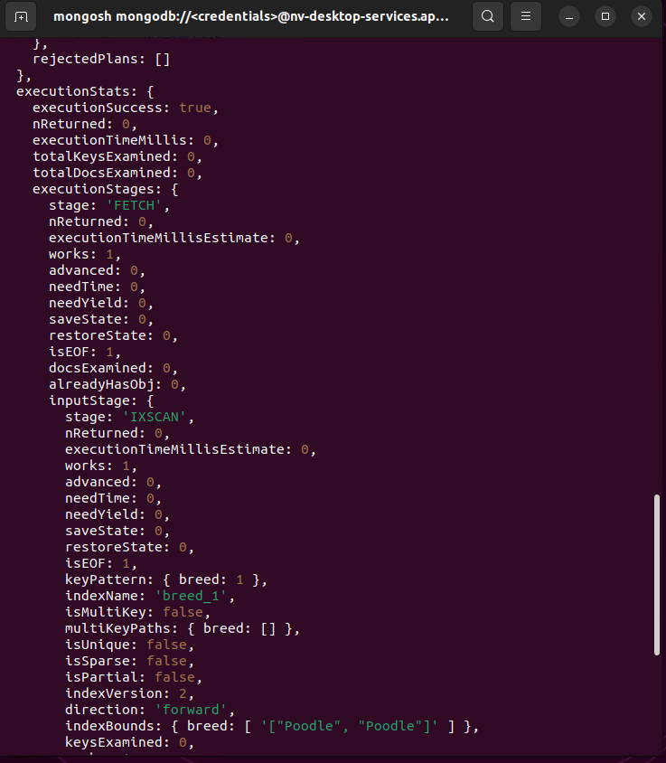

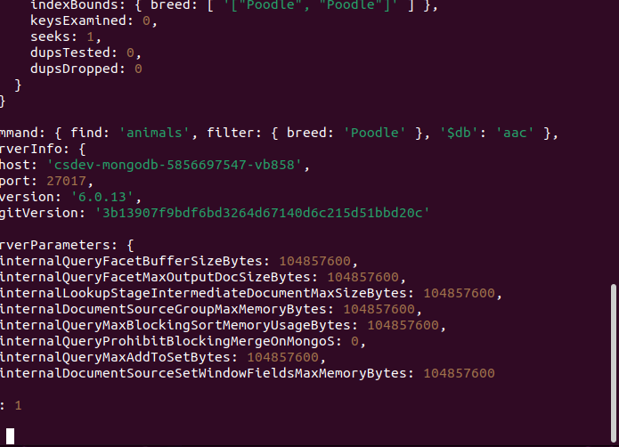

After setting up the indexes, I performed a query to find animals of the "Poodle" breed and those with an outcome type of "Transfer." I used the explain('executionStats') method to analyze the performance of the queries and ensure the indexes were utilized effectively. This step demonstrated the importance of indexing for optimizing database queries.

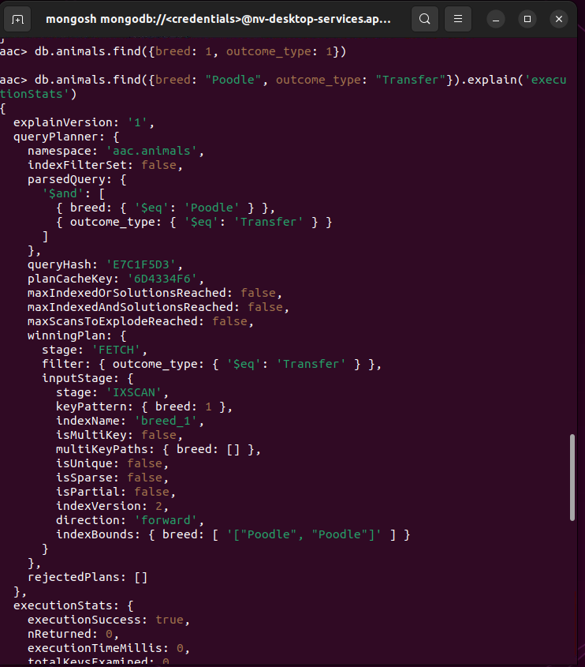

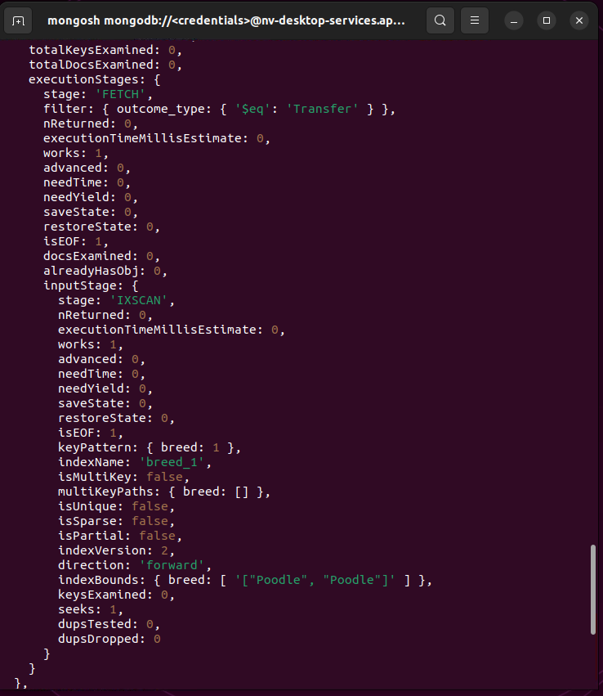

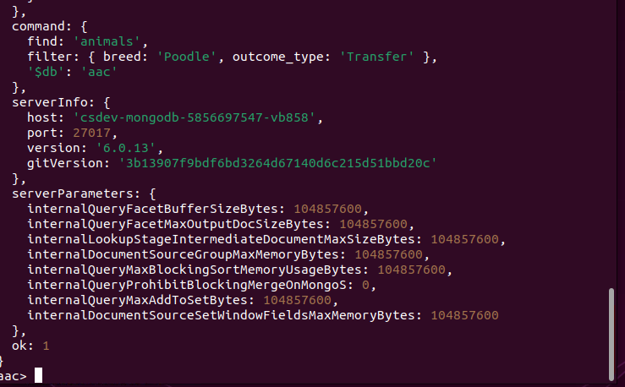

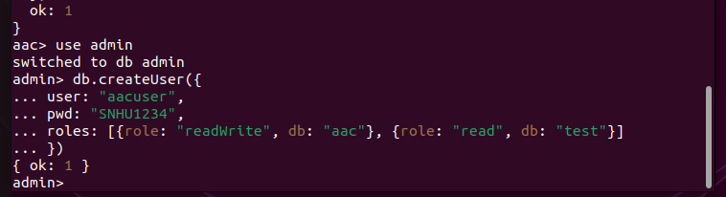

I then switched to the "admin" database and created a new user with specific roles for accessing the "aac" database and reading from the "test" database. This ensured secure and role-based access to the data. Finally, I set up environment variables for the MongoDB credentials and verified their values using the printenv command. This made it easier to manage connection details securely without hardcoding them into commands.

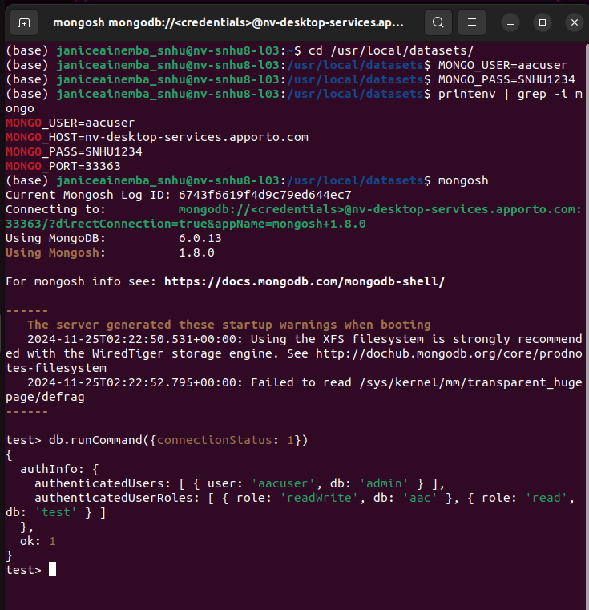

To confirm everything was set up correctly, I ran a command to check the connection status and authenticated roles, ensuring the user had the expected permissions for interacting with the database. This process helped establish a secure and optimized environment for working with MongoDB data.